Week 1
Session 2 - 1
Code :
import java.util.*;

class Student {
private final int id;
private final String fname;
private final double cgpa;

public Student(int id, String fname, double cgpa) {
this.id = id;
this.fname = fname;
this.cgpa = cgpa;
}

public int getId() { return id; }
public String getFname() { return fname; }
public double getCgpa() { return cgpa; }
}

public class Solution {
public static void main(String[] args) {
Scanner in = new Scanner(System.in);

if (!in.hasNextInt()) {
in.close();
return;
}

int testCases = in.nextInt();
List<Student> studentList = new ArrayList<>();

while (testCases > 0 && in.hasNext()) {
int id = in.nextInt();
String fname = in.next();
double cgpa = in.nextDouble();

studentList.add(new Student(id, fname, cgpa));
testCases--;
}
in.close();

// Safe Java 8+ fluent sorting chain
studentList.sort(Comparator.comparing(Student::getCgpa).reversed()
.thenComparing(Student::getFname)
.thenComparing(Student::getId));

// Output results
for (Student st : studentList) {
System.out.println(st.getFname());
}
}
}

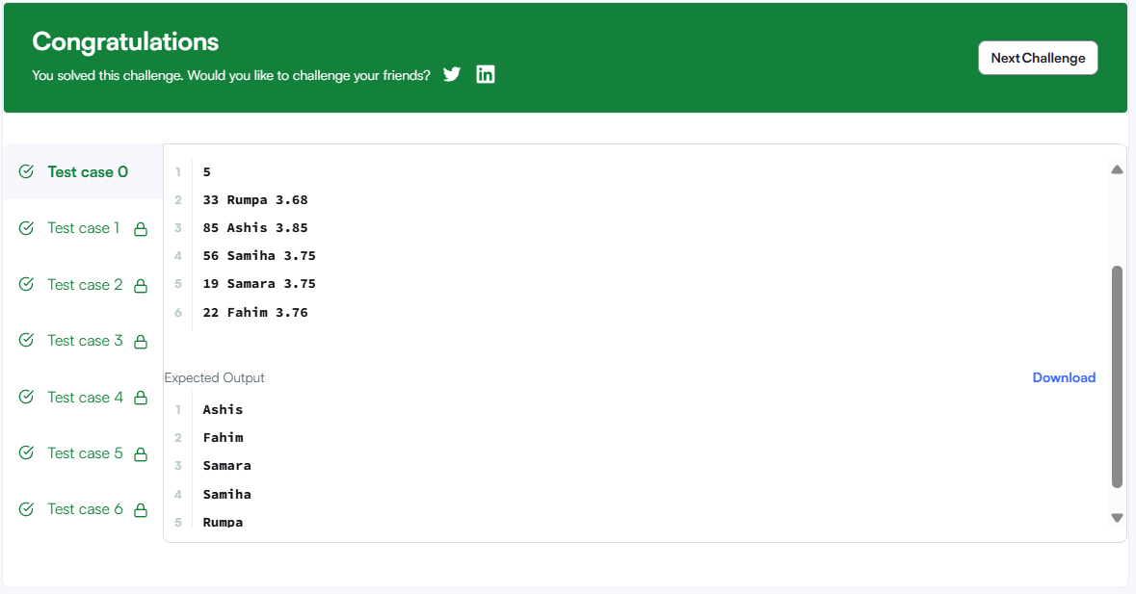

Session 2 - 2
Code :

class Solution {
public int[] sortArrayByParity(int[] nums) {
int left = 0;
int right = nums.length - 1;

while (left < right) {
// If the left element is odd and right is even, swap them
if (nums[left] % 2 != 0 && nums[right] % 2 == 0) {
int temp = nums[left];
nums[left] = nums[right];
nums[right] = temp;
}

// Move pointers inward if they are already in the correct place
if (nums[left] % 2 == 0) {
left++;
}
if (nums[right] % 2 != 0) {
right--;
}
}

return nums;
}
}

